# ST.XAVIER’S COLLEGE

# MAITIGHAR, KATHMANDU



**ASSIGNMENT #9**

**Database Management System**

**Submitted By:**

Suman Malla

013BSCCSIT041

**Submitted To:**

______________________

Er. Sanjay Kumar Yadav

Department of Computer Science

Lecturer

**Database recovery**

Data Recovery Is A Process Of Salvaging Inaccessible Data From Corrupted Or Damaged [Secondary Storage](https://en.wikipedia.org/wiki/Secondary_storage), [Removable Media](https://en.wikipedia.org/wiki/Removable_media) Or [Files](https://en.wikipedia.org/wiki/Computer_file), When The Data They Store Cannot Be Accessed In A Normal Way. The Data Is Most Often Salvaged From Storage Media Such As Internal Or External [Hard Disk Drives](https://en.wikipedia.org/wiki/Hard_disk_drive) (Hdds), [Solid-State Drives](https://en.wikipedia.org/wiki/Solid-state_drive) (Ssds), [Usb Flash Drives](https://en.wikipedia.org/wiki/USB_flash_drive), [Magnetic Tapes](https://en.wikipedia.org/wiki/Magnetic_tape_data_storage), [Cds](https://en.wikipedia.org/wiki/CD), [Dvds](https://en.wikipedia.org/wiki/DVD), [Raid](https://en.wikipedia.org/wiki/RAID) Subsystems, And Other Electronic Devices. Recovery May Be Required Due To Physical Damage To The Storage Device Or Logical Damage To The [File System](https://en.wikipedia.org/wiki/File_system) That Prevents It From Being [Mounted](https://en.wikipedia.org/wiki/Mount_(computing)) By The Host [Operating System](https://en.wikipedia.org/wiki/Operating_system) (Os).

The Most Common Data Recovery Scenario Involves An Operating System Failure, Malfunction Of A Storage Device, Accidental Damage Or Deletion, Etc. (Typically, On A Single-Drive, Single-[Partition](https://en.wikipedia.org/wiki/Disk_partition), Single-Os System), In Which Case The Goal Is Simply To Copy All Wanted Files To Another Drive. This Can Be Easily Accomplished Using A [Live Cd](https://en.wikipedia.org/wiki/Live_CD), Many Of Which Provide A Means To [Mount](https://en.wikipedia.org/wiki/Mount_(computing)) The System Drive And Backup Drives Or Removable Media, And To Move The Files From The System Drive To The Backup Media With A [File Manager](https://en.wikipedia.org/wiki/File_manager) Or optical. Such Cases Can Often Be Mitigated By [Disk Partitioning](https://en.wikipedia.org/wiki/Disk_partition) And Consistently Storing Valuable Data Files (Or Copies Of Them) On A Different Partition From The Replaceable Os System Files.

Another Scenario Involves A Drive-Level Failure, Such As A Compromised [File System](https://en.wikipedia.org/wiki/File_system) Or Drive Partition, Or A [Hard Disk Drive Failure](https://en.wikipedia.org/wiki/Hard_disk_drive_failure). In Any Of These Cases, The Data Cannot Be Easily Read. Depending On The Situation, Solutions Involve Repairing The File System, Partition Table Or [Master Boot Record](https://en.wikipedia.org/wiki/Master_boot_record), Or Drive Recovery Techniques Ranging From Software-Based Recovery Of Corrupted Data, Hardware- And Software-Based Recovery Of Damaged Service Areas (Also Known As The Hard Disk Drive's "Firmware"), To Hardware Replacement On A Physically Damaged Drive. If A Drive Recovery Is Necessary, The Drive Itself Has Typically Failed Permanently, And The Focus Is Rather On A One-Time Recovery, Salvaging Whatever Data Can Be Read. The Term "Data Recovery" Is Also Used In The Context Of [Forensic](https://en.wikipedia.org/wiki/Computer_forensics) Applications Or [Espionage](https://en.wikipedia.org/wiki/Espionage), Where Data Which Have Been [Encrypted](https://en.wikipedia.org/wiki/Encryption) Or Hidden, Rather Than Damaged, Are Recovered.

**Purpose Of Data Recovery**

As a backup administrator, your principal duty is to devise, implement, and manage a backup and recovery strategy. In general, the purpose of a [backup and recovery](http://docs.oracle.com/cd/B28359_01/backup.111/b28270/glossary.htm#i432085) strategy is to protect the database against data loss and reconstruct the database after data loss. Typically, backup administration tasks include the following:

* Planning and testing responses to different kinds of failures
* Configuring the database environment for backup and recovery
* Setting up a backup schedule
* Monitoring the backup and recovery environment
* Troubleshooting backup problems
* Recovering from data loss if the need arises
* Application Errors
* Data Protection
* Media Failures

**Types Of Failure**

Transaction failure: Individual transactions fail

Logical error: Internal problem within the transaction

System error: External problem during transaction execution (e.g., deadlock)

System crash: Problem with overall database server execution; terminates the current process

Fail-stop assumption: Data in non-volatile storage is unharmed in the event of a system crash

Disk failure: Problem with storage media

**3) The storage hierarchy**

The range of memory and storage within and attached to a computer system is known as the Storage Hierarchy and to help understand this further can be categorised into 4 segments. As memory and storage devices move down the hierarchy they reduce in performance and cost/MB or GB but tend to rise in capacity through to the last category which includes removable media which in effect has no restriction on capacity a device can store.[4]

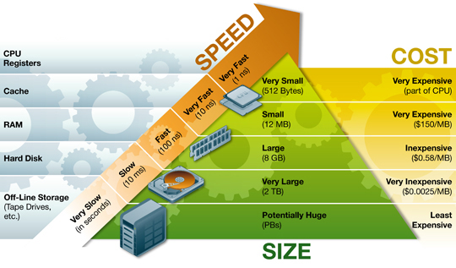

Primary Storage is the top level and is made up of CPU registers, CPU cache and memory which are the only components that are directly accessible to the systems CPU. The CPU can continuously read data stored in these areas and execute all instructions as required quickly in a uniform manner. Secondary Storage differs from primary storage in that it is not directly accessible by the CPU. A system uses input/output (I/O) channels to connect to the secondary storage which control the data flow through a system when required and on request

Secondary storage is non-volatile so does not lose data when it is powered down so consequently modern computer systems tend to have a more secondary storage than primary storage. All secondary storage today consist of hard disk drives (HDD), usually set up in a RAID configuration, however older installations also included removable media such us magneto optical or MO

Tertiary Storage is mainly used as backup and archival of data and although based on the slowest devices can be classed as the most important in terms of data protection against a variety of disasters that can affect an IT infrastructure. Most devices in this segment are automated via robotics and software to reduce management costs and risk of human error and consist primarily of disk & tape based back up devices

Offline Storage is the final category and is where removable types of storage media sit such as tape cartridges and optical disc such as CD and DVD. Offline storage is can be used to transfer data between systems but also allow for data to be secured offsite to ensure companies always have a copy of valuable data in the event of a disaster.

**4) Buffer Management**

A DBMS must manage a huge amount of data, and in the course of processing the required space for the blocks of data will often be greater than the memory space available. For this there is the need to manage a memory in which to load and unload the blocks. The buffer manager is responsible primarily for managing the operations inherent saving and loading of the blocks. In fact, the operations that provide the buffer manager are these:

* FIX: This command tells the operator of the buffer to load a block from disk and return the pointer to the memory where it is loaded. If the block was already in memory, the buffer manager needs only to return the pointer, otherwise he must load from disk and bring it into memory.[5]

* SET DIRTY: invoking this command, you mark a block of memory as amended.[5]

* Force: This command will cause the operator of the buffer to make the writing in synchronously with the completion (commit) the transaction* FLUSH: This command will cause the operator of the buffer to perform the rescue, when in how NOT FORCE.[5]

Log: Sequence of records (sequential file)

Modified by appending (no updating)

• Contains information from which database can be restored

• Log and database stored on different mass storage devices

• Often replicated to survive single media failure • Contains valuable historical data not in database

**5) Transaction Log**

Scan log backwards using tid to identify transaction’s update records

• Reverse each update using before image

• In a strict system, new values are unavailable to concurrent transactions (as a result of long term exclusive locks); hence rollback makes transaction atomic

• Problem: terminating scan (log can be long) • Solution: append begin record containing tid prior to first update record[3]

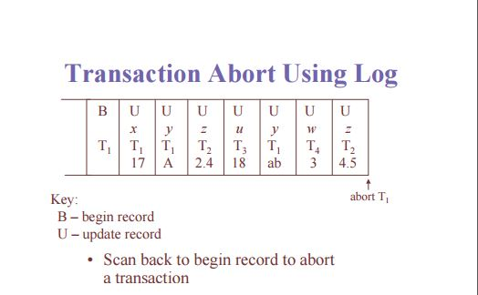

**6) Data Updates**

The Update and Update All methods allows the updating of data already in your database. The return value of an Update method is the number of rows that were just updated.

You can Update using two forms, Named parameters and by object. The object can be a POCO or a dynamic (i.e.ExpandoObject).

_db.Users.UpdateById(Id: 1, Name: "Steve", Age: 50);

Note: There are differences in the generated SQL when using Named Parameters or object, where the object includes all properties including on the object, but the Named Parameters only includes those you specify

**7) Data Caching**

The Database Management System (DBMS) is a memory buffer which stores copies of portions of the database that the DBMS is currently using. Reading from memory is much faster than reading from the disk. The DBMS therefore returns a record more quickly if it is already stored in cache. As long as the required data is stored in cache, the data is immediately available. When the required data is not stored in cache, it must be copied from the disk and then stored in cache.[6]

**8) Transaction Roll back (Undo) and Role Foreword**

**9) Check pointing, shadow paging**

**10) Recovery Schemes (WAL: write ahead logging protocol)**

**11) Failure with loss of non-volatile storage (General Concept)**

**12) Recovery in database system**

**Reference**

[1] <http://searchdisasterrecovery.techtarget.com/definition/data-recovery>

[2] <http://holowczak.com/database-recovery/>

[3] <https://webdocs.cs.ualberta.ca/~zaiane/courses/cmput391/slides/L9-391-04.pdf>

[4] <http://www.ts.avnet.com/uk/products_and_solutions/storage/hierarchy.html>

[5] <http://www.scribd.com/doc/49586450/The-Buffer-Manager-of-a-DBMS#scribd>

[6] <https://msdn.microsoft.com/en-us/library/dd355169.aspx>